MDM - MGSS Bulk Data Extracton and TRANFER TOOL UAT Test cases

Contents
1. User System Access Test Cases 2
2. Auto Scheduler Setting 3
3. Initial Data Extract 5
4. Delta Data Extract 11
5. Bosch Test Cases 12

MGSS Bulk Data Extraction and Transfer Project
UAT Test Cases
- UAT Test Case Summary:
# | Test Cases Processes | No. of Test Cases | No. of Success | No. of failure | Status
1 | User System Access | 2
2 | Auto Scheduler Setting | 2
3 | Initial data extract | 5
4 | Delta data extract | 1
5 | Bosch Test Cases | 2
7 | Rest Full Data Extraction Button Feature | 2
8 | Reset Delta Data Update Button Feature | 3
 | Total | 17

User System Access Test Cases
- Users should be able to login into MDM using below URL for applicable environment. Below URLs are related to MGSS MNAO market. User can access MDM based on its regional MDM URL too. User should have MDM MazdaAce Admin role in IM Profile to view the below “MGSS Bulk Data Export and Transfer Tool” module in MDM.
QA: https://na.qa.mgss.customerservice.mazda.com/okmdmgt/mypage
Expected Result: User should be able to view below MDM application Landing Page and should be able to view “MGSS Bulk Data Export and Transfer Tool” on MDM Landing Page.
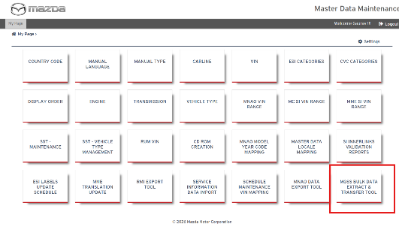
Status: Pass/Fail
Remarks:

- User will click on “MGSS Bulk Data Extract and Transfer Tool” title on Landing page
Expected Result: User should be able to view below page which shows schedule setting and Models available for auto schedule / on Demand where Model Year is >=2012 Year in MDM Carline data for en_US locale.

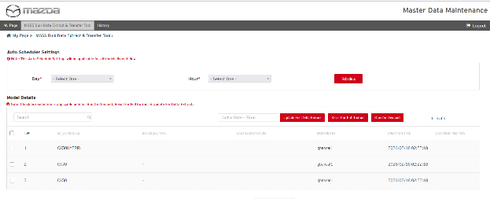
Status: Pass/ Fail
Remarks:

Auto Scheduler Setting
- Users should be able to set the schedule for all models using schedule setting where users set the day and hour to auto trigger the monthly job extraction.
Expected Result:
Once schedule setting is set, user will view the message “schedule details have saved successfully” given in above screenshot.
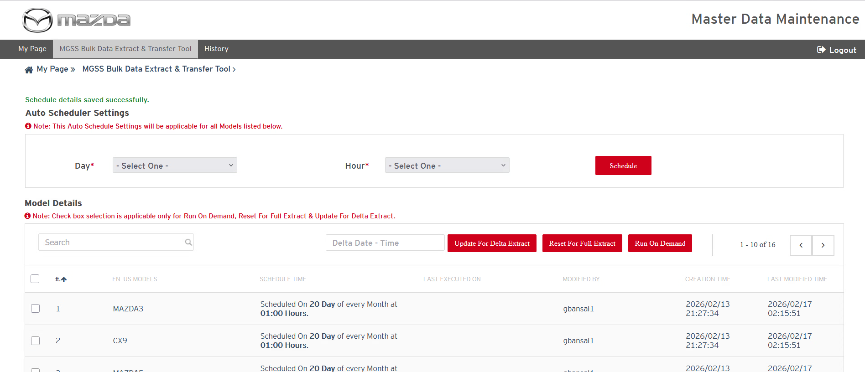
Note: Scheduler job triggers in every hour to verify the latest schedule timing. Whenever user set the schedule, so user needs to make sure that schedule timing and scheduler job is having min. one hour difference to auto trigger the monthly data extraction job.
Status: Pass/ Fail
Remarks:
- User should be able to view the latest schedule time for every model in below list of Model in “Schedule Time” column.
Expected Result:
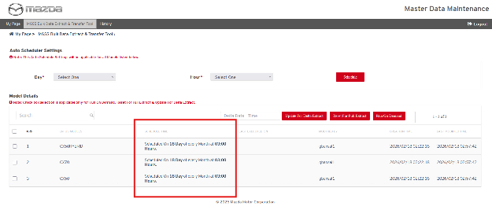

Status: Pass/ Fail
Remarks:

Initial Data Extract
- User should be able to use “Run on Demand” button to extract the full data for any existing MGSS Model content where user should select any particular model and click on “Run On demand” button
Expected Result:
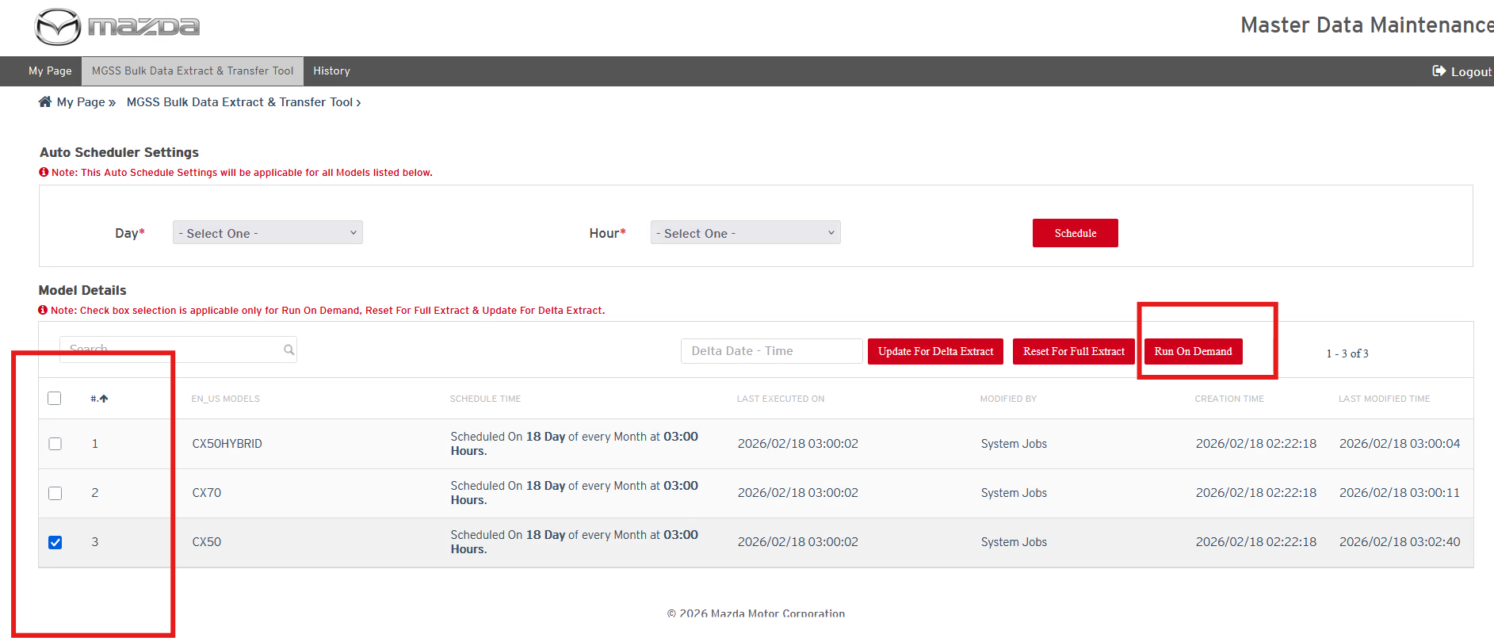
Status: Pass / Fail
Remarks:

- Once the on demand job is scheduled then system will take time to start job processing in between 0-5 min. and user should be able to view the message on “MGSS Bulk Data extract and transfer tool” screen as show in below screenshot.
Expected Result:
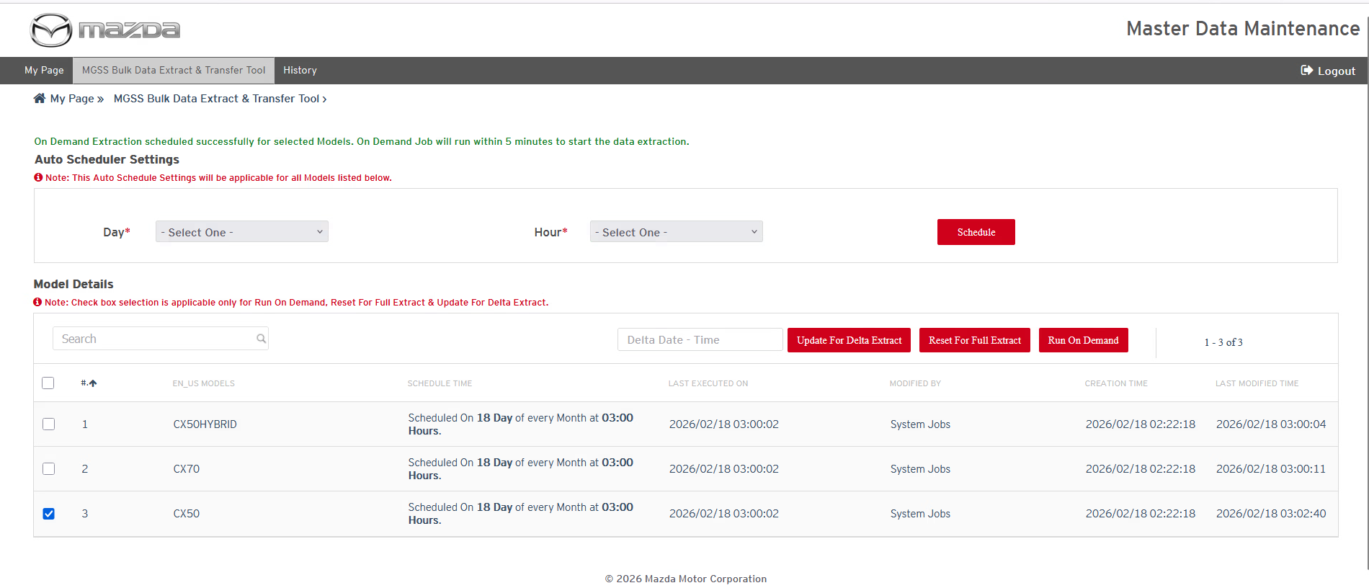
Status: Pass/ Fail
Remarks:
- Once the job is stated then user should be able to view the job in Job Running Status as “In Progress”, it means that content extraction started
Expected Result: At least One of the following count should be progressing
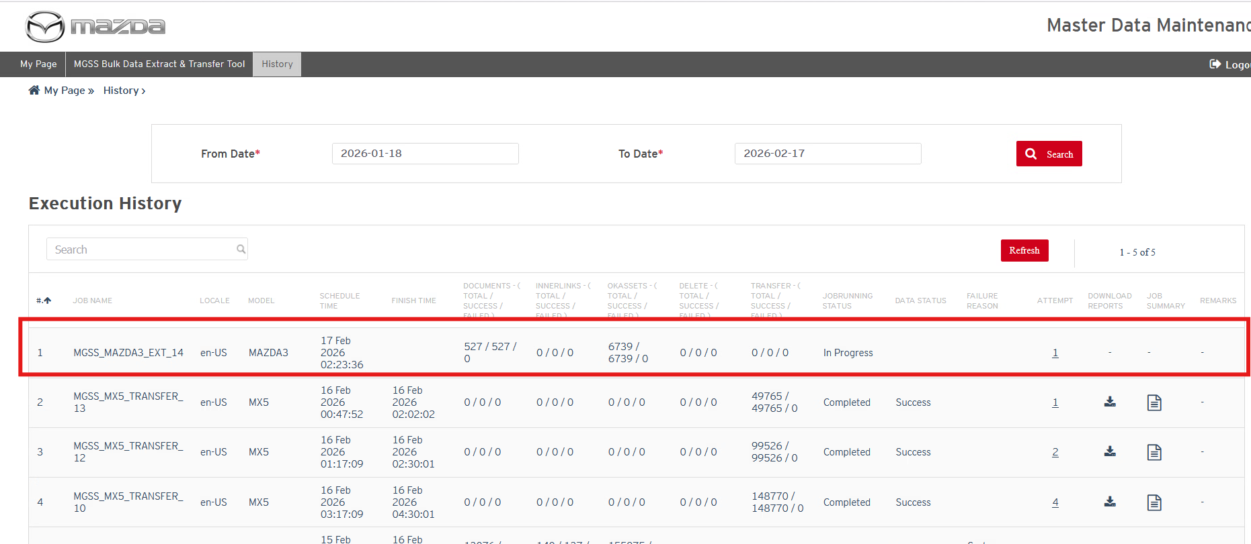
- Documents [Total/ Success/ Failed]
- Inner Links [Total/ Success/ Failed]
- OKAssets [Total/ Success/ Failed]
- Delete [Total/ Success/ Failed]
Status: Pass/ Fail
Remarks:
- If Extraction job Running Status “Completed” and Data job status is “Success”, it means that there was no issue in data extraction and transfer job should be started to transfer data from MGSS file server to OCI storage env. User will also get an email notification on extraction Job completion.
Expected Result:
- User should be able to download the reports in MDM history page using “Download reports” for that completed job.
- User should be able to view the extracted data on MGSS file server in required folder structure.
- User should be able to view the transfer job record in “In Progress” status on history page.
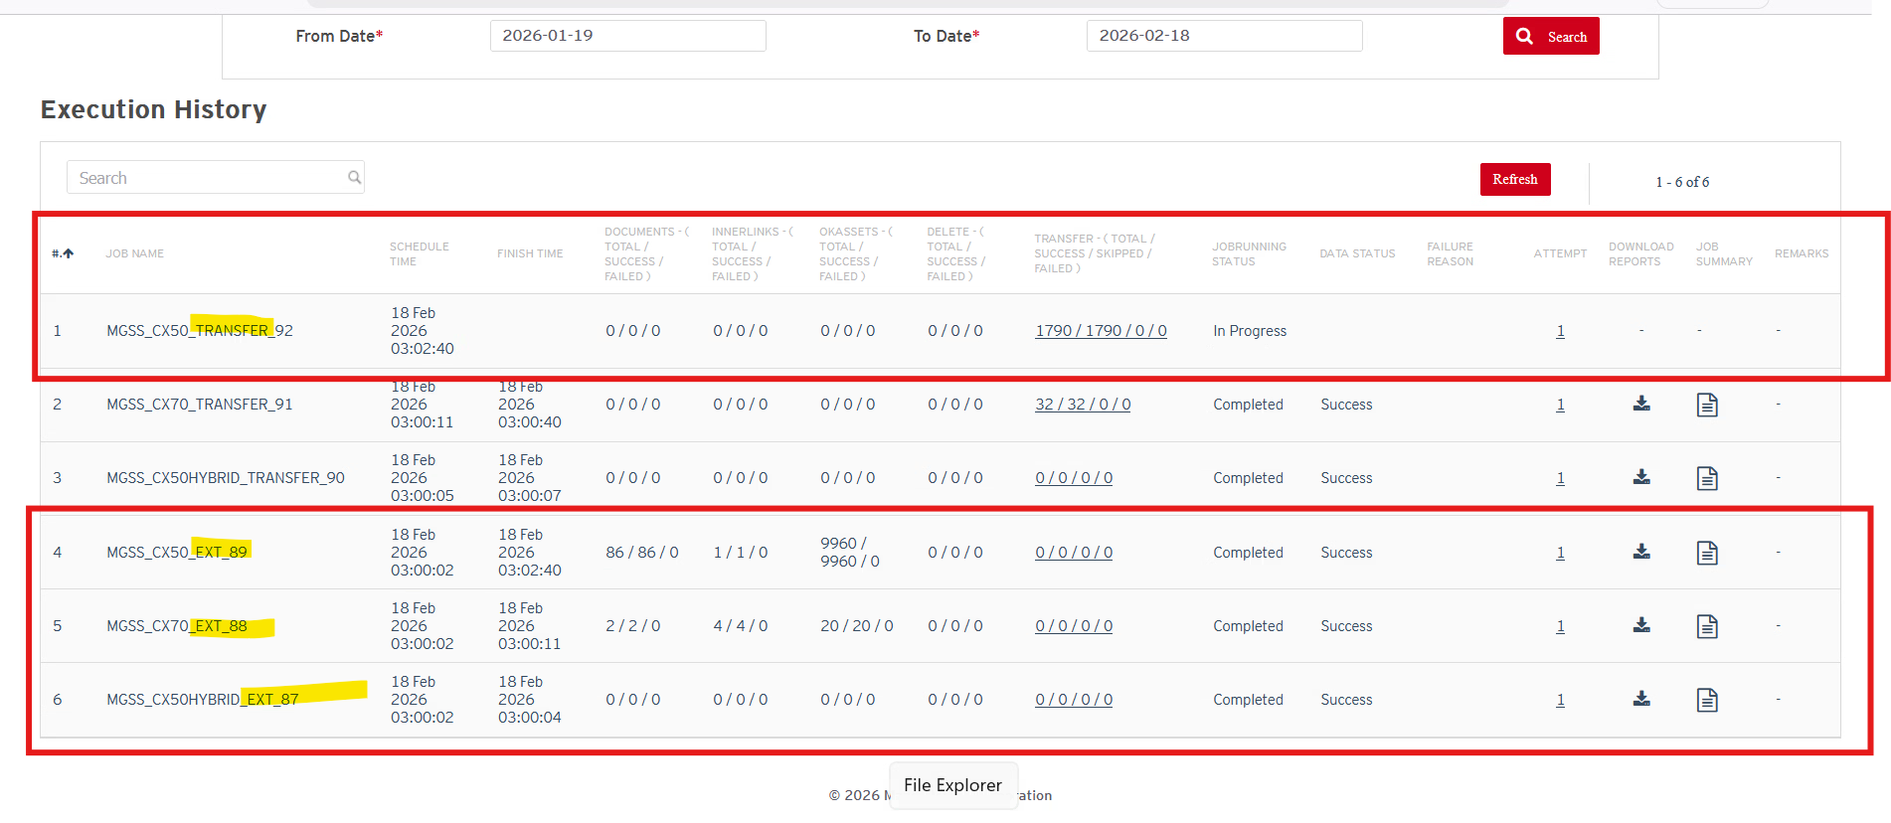
Status: Pass/ Fail
Remarks:
- If Transfer job Running Status “Completed” and Data status is “Success”, it means that extracted data should have copied on OCI storage. User can download the MDM report for transfer job to verify the transferred data on OCI Storage.
Expected Result:
- User should be able to view the transfer job status with “Complete” and data status with “Success” on MDM history page and transfer (Total/ Success/ Failed) count updates too which are moved to OCI storage.
- User can view how many files are transferred/ Skipped/ failed in OCI storage with with below popup
- User can download the reports for completed transfer job from MDM history page fr analysis
- Users can view the transferred content on OCI storage location in required folder structure.
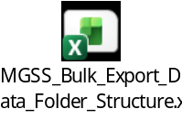

Click on Extract Transfer Job Report in MDM History page:
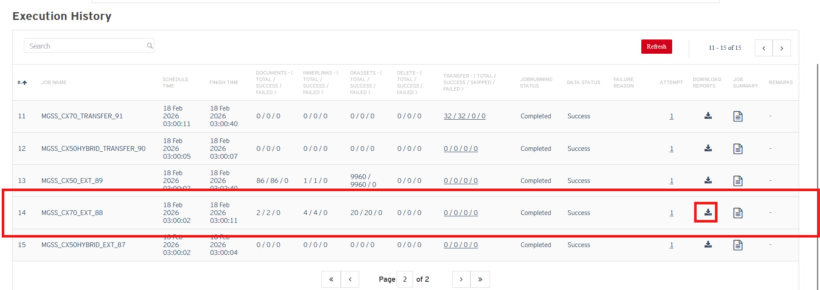

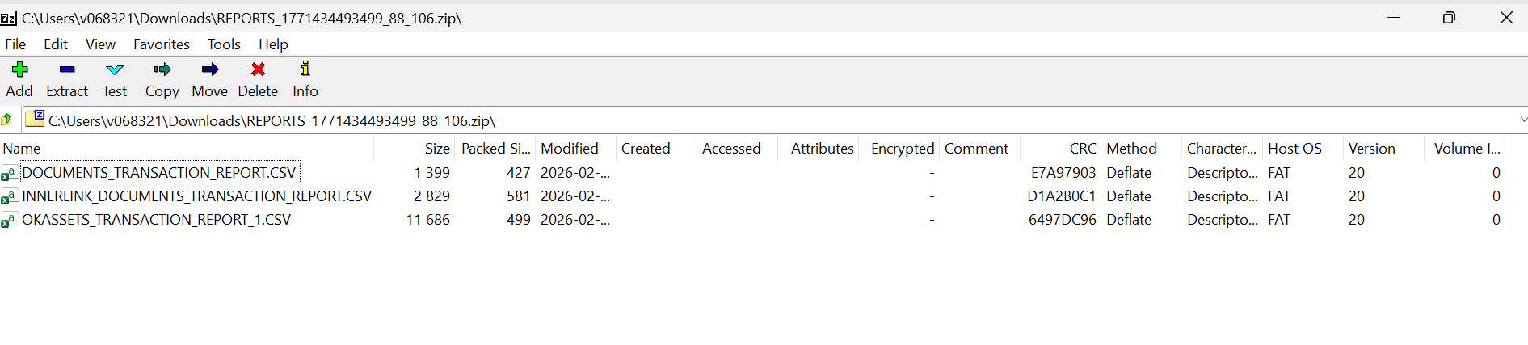
Click on Transfer Job status link below:
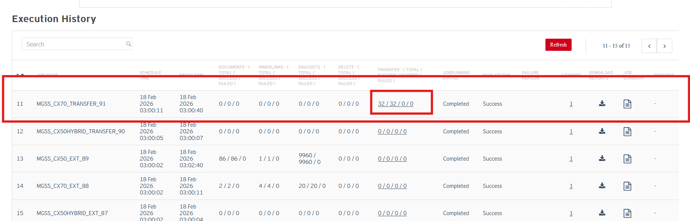

On click following popup will appear, which will confirm that how many files are transferred in OCI full data storage and in OCI delta data storage

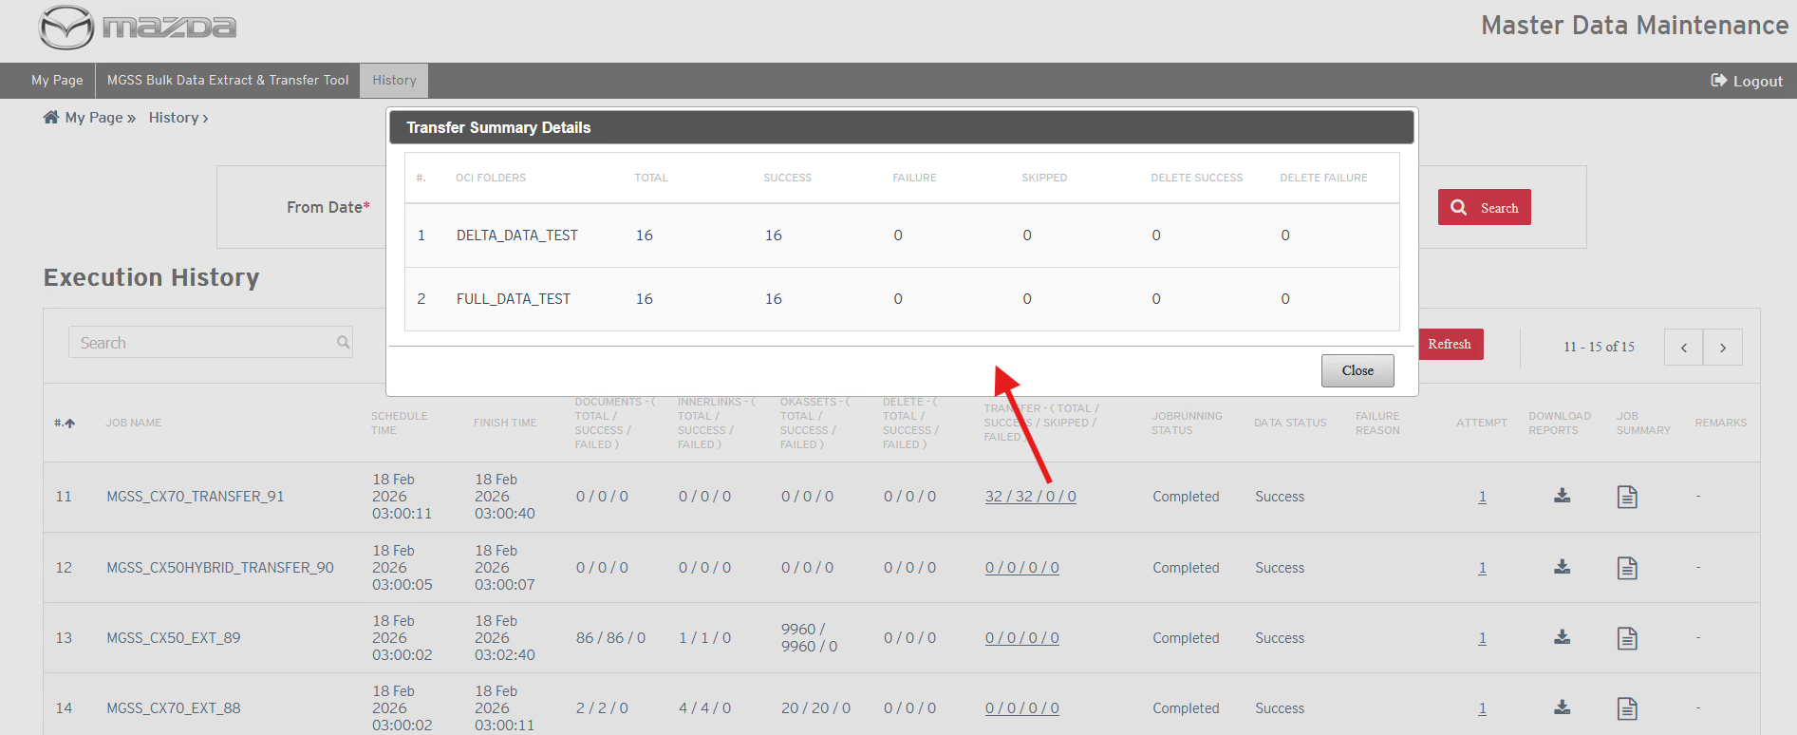

After that, Click on download report icon below in History page:
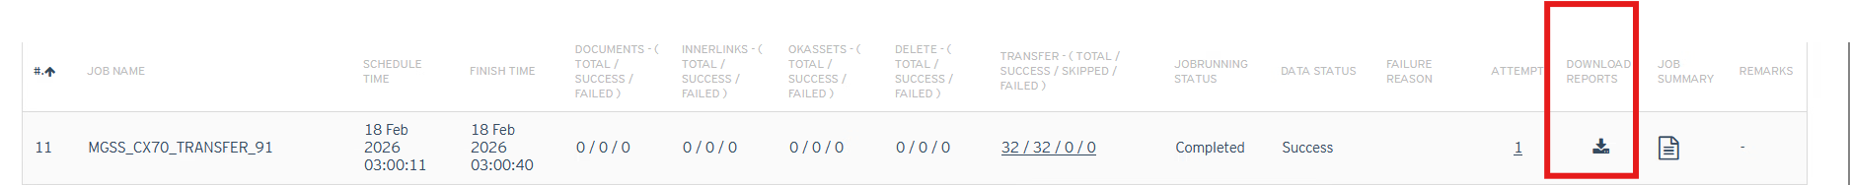
Report Downloaded:
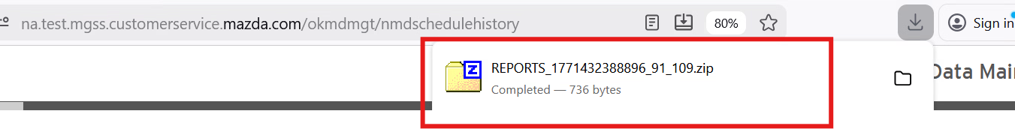

User can open Transfer_report.csv file and can filter file path with “Delta_Data” or “Full_Data” related content to view what files are synched in Full_Data folder or Delta data folder in OCI storage.
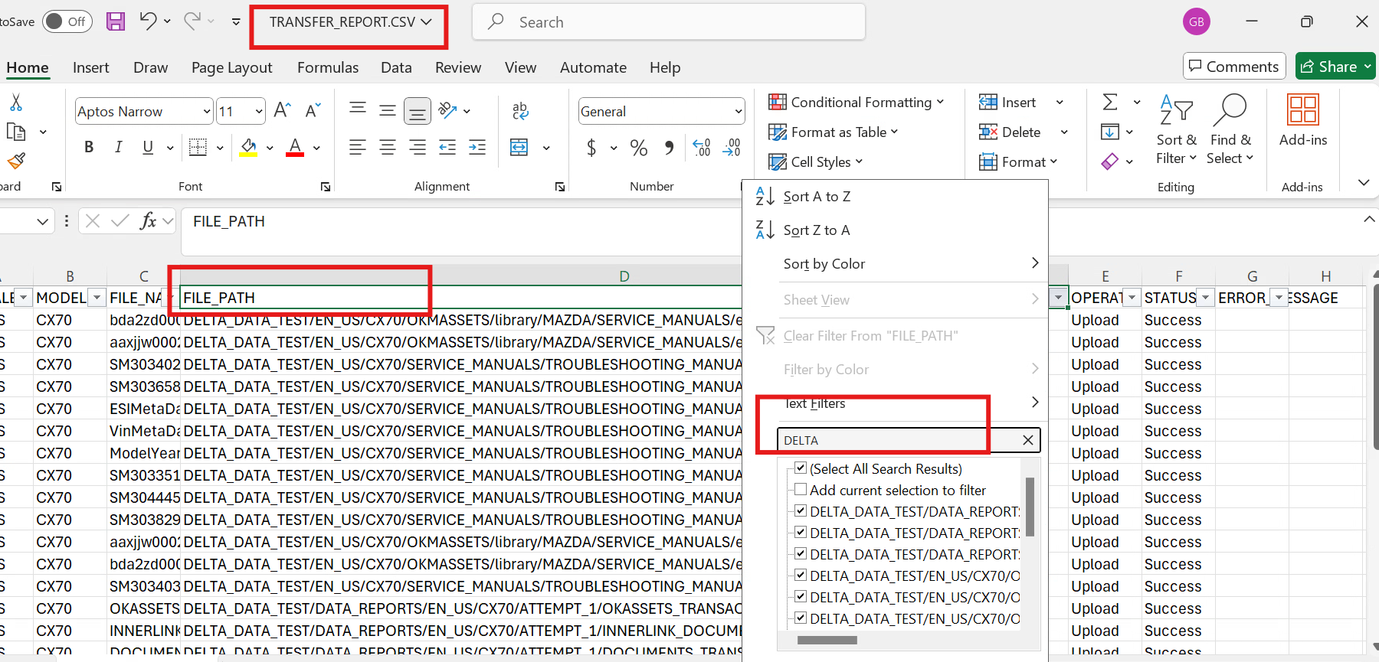

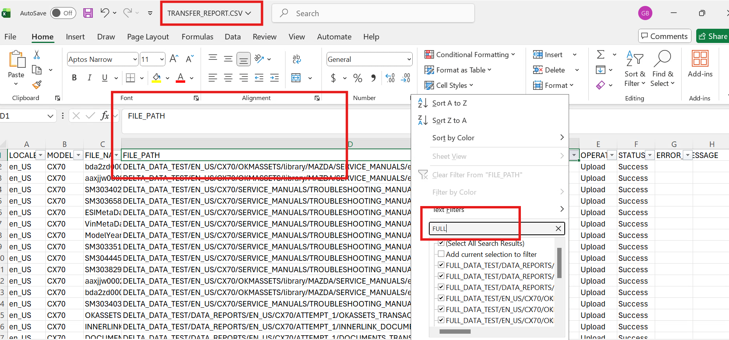

Status: Pass/ Fail
Remarks:

Delta Data Extract
- User can extract the delta data extraction and transfer the data on OCI storage. Following steps are supposed to be performed to execute this test case. Delta Content should be extracted from “Last Executed On” timestamp to Current Job runtime.
Step 1: Prepare delta data for initial extracted model with following:
  - Add new file or delete existing file or modify existing file for initial extracted model:
    - IF SM or WD documents are added/ modified/ deleted then migrate delta content using DMT tool.
    - If SI Document, then user can create a new document in IM and wait for sometime until SI document is not synced in OK_DC database table by batch job.
Note: User can take MGSS Support team support to perform above activity as needed.
Step 2: Get confirmation from Bosch team on Intial data download and content validation
Step 3: Once Delta content is loaded and ready for extract then perform UAT.0005 to UAT.00010 UAT Test cases for delta data extract and Transfer on OCI Storage as mentioned above.
Expected results:
- Delta data extraction should be based on “Last Executed On” timestamp and current Delta Extraction job Schedule timestamp.

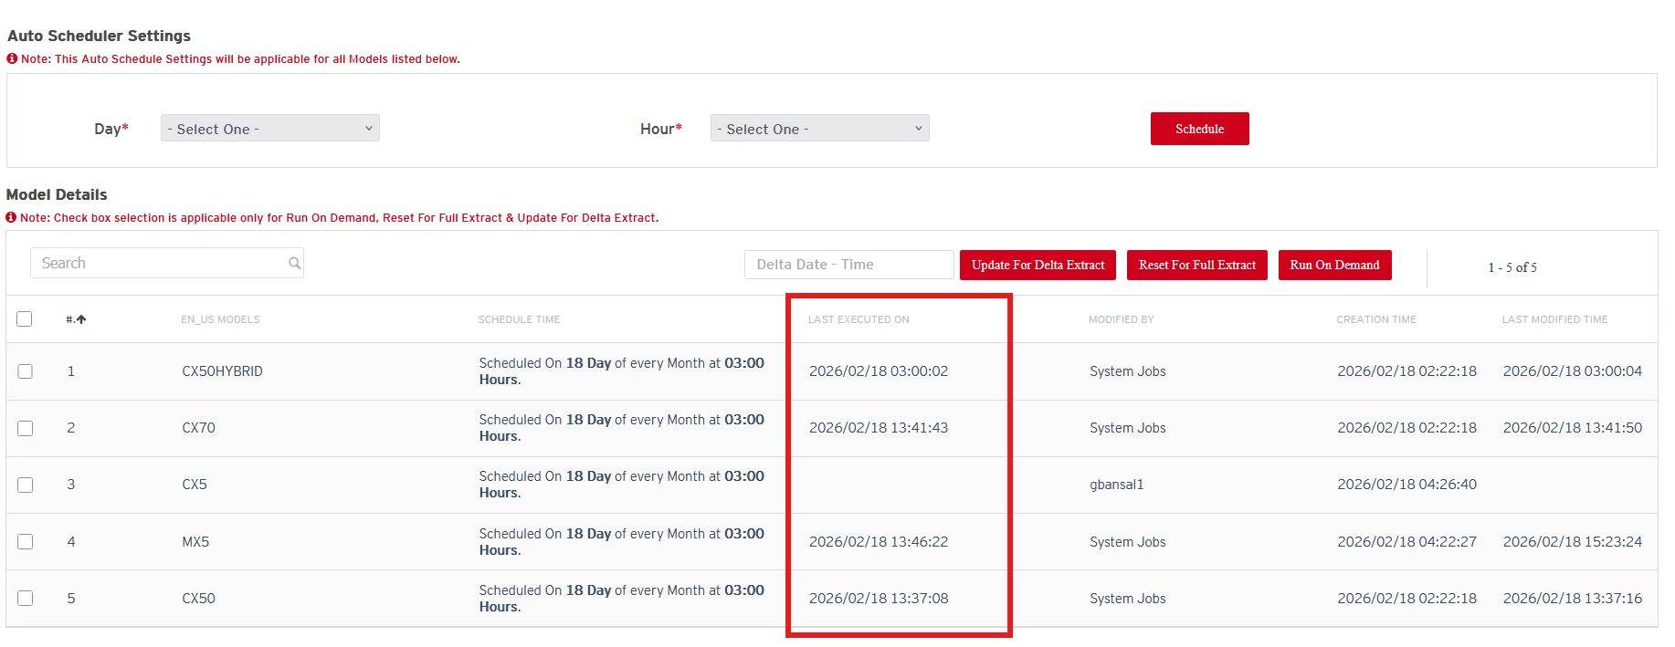
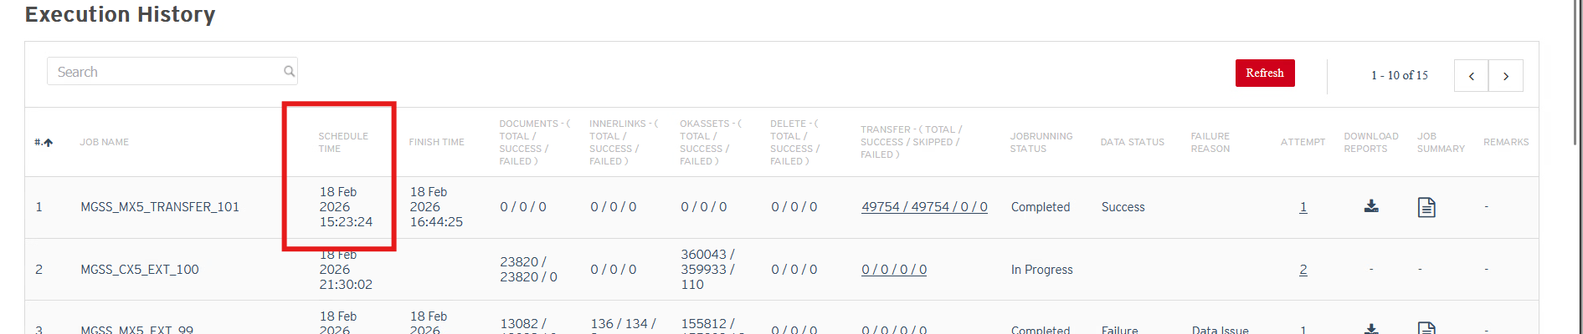

- With delete delta content to generate delete.csv file in MDM data extraction job report.
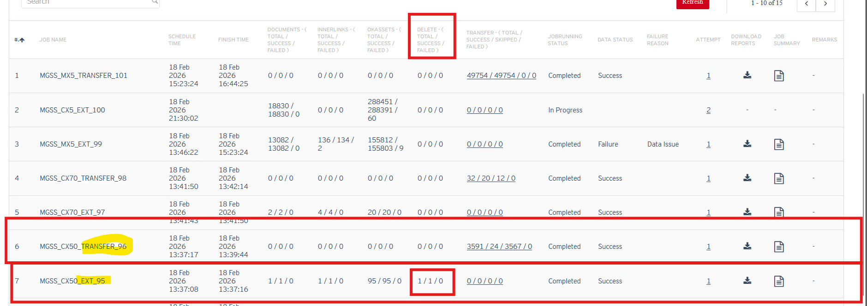

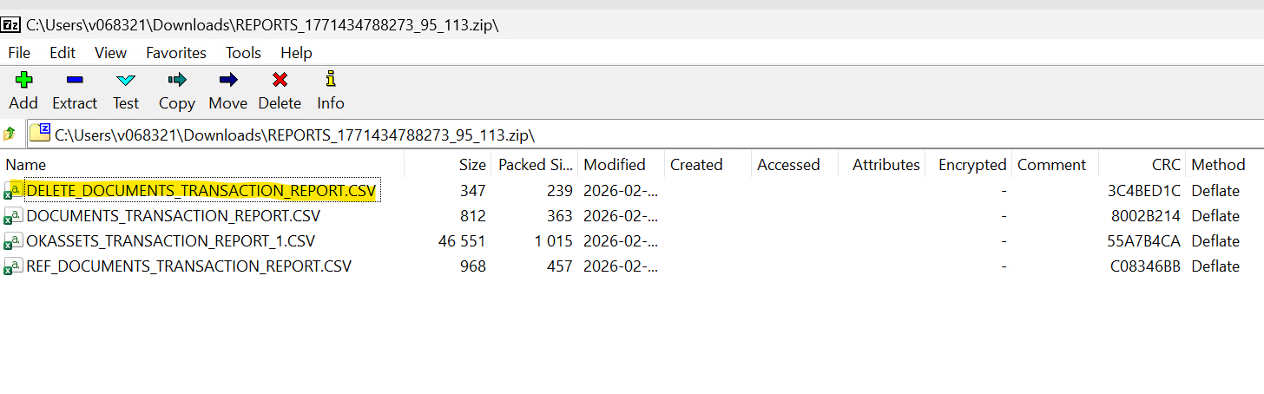

- For existing document modification:
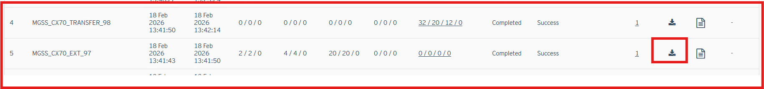

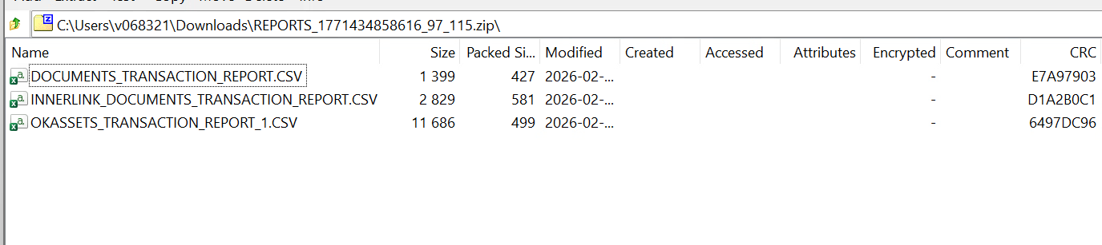

Bosch Test Cases
- Bosch Team should be able to download the full content from Delta_Data folder from OCI Storage without delete.csv file and delete the folder from OCI storage
Expected Steps to follow:
- Bosch team downloads the content from Delta_Data folder for initial data
- Delete the folder from OCI storage
- Validate the extracted content and confirm whether content is as per expectation and in parse / readable format.
- Confirm the results to MC team. If content is as per expectation, then MC should be able to start delta data exaction and transfer on initial model data extract.
Expected results:
All above steps should be executed and passed

Status: Pass/ Fail
Remarks:

- Bosch team should be able to download the delta data content and delete the delta data folder
Expected Steps to follow:
- Bosch team downloads the content from Delta_Data folder for delta data
- Delete the folder from OCI storage
- Validate the extracted content and confirm whether content is as per expectation and in parse / readable format.
- If content is having delete.csv file then Bosch team should be able to use the delete.csv file information and should be able to delete the file from initial downloaded data
- Confirm the results to MC team with UAT results
Expected results:
All above steps should be executed and passed

Status: Pass/ Fail
Remarks:

Reset Full Data Extract Button Feature
- If user wants to extract the full content anytime of particular selected model anytime in system then user can press the “Rest for Full Data Extract” button and can set the “Last Executed On” timestamp with blank value then Auto scheduler or on Demand schedule should re-extract the full data for that model.
Expected Result:
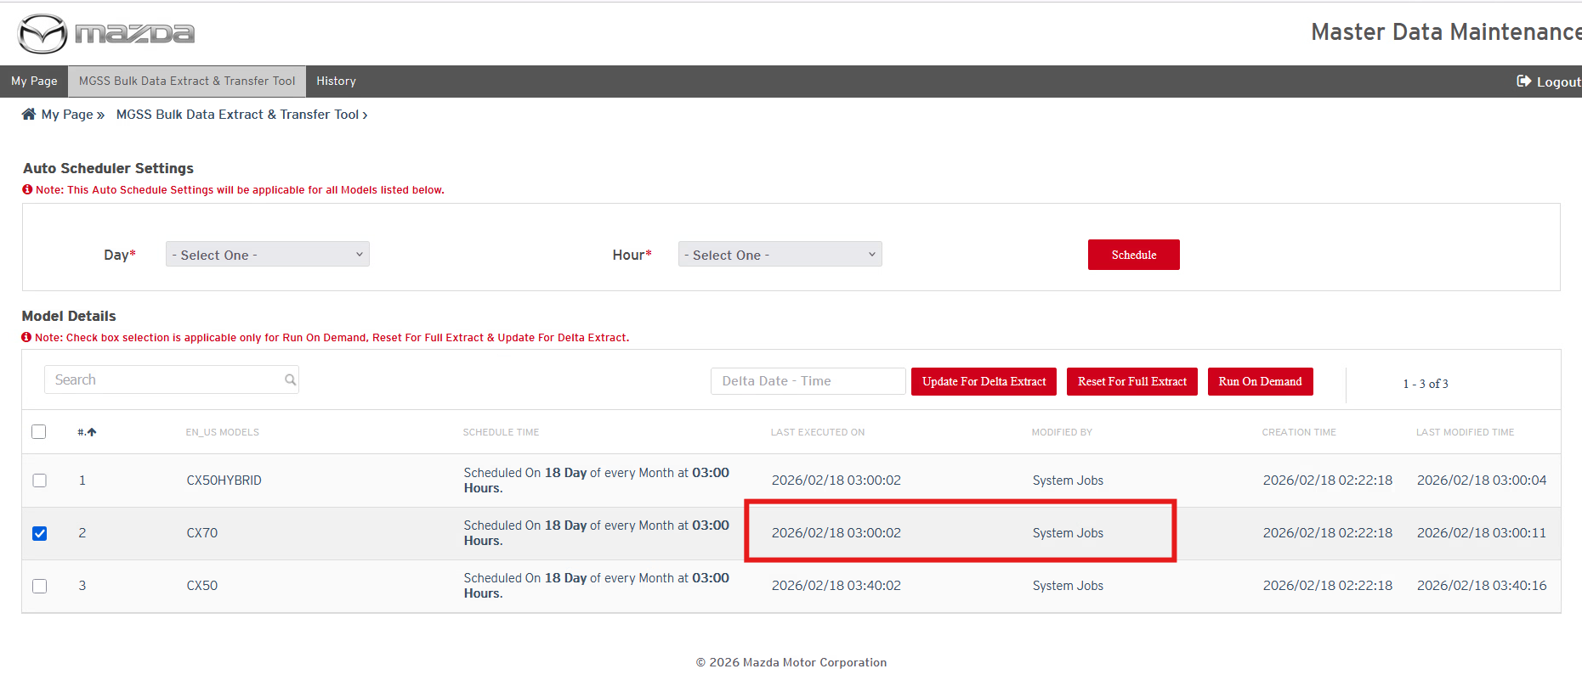
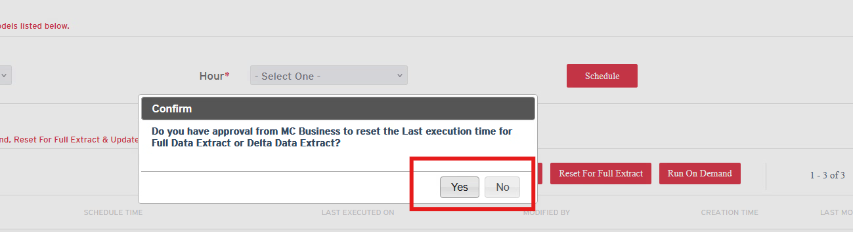
If user click on “Yes”, then it will reset ‘last executed on’ time to blank. If user click on “No” then it will not reset the existing “last executed on” timestamp.
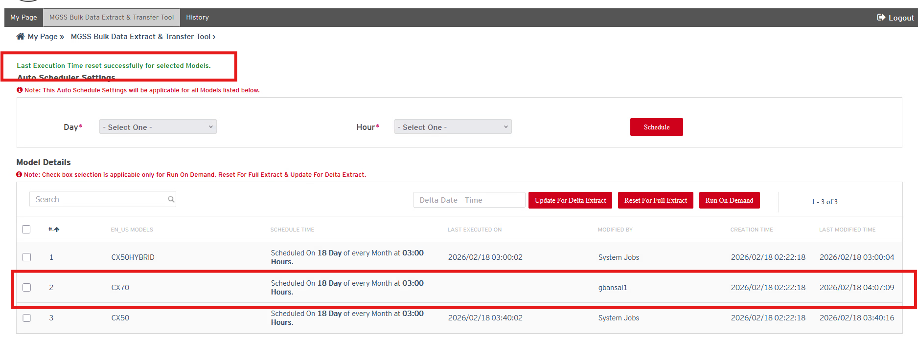
Status: Pass
Remarks:
- If user selects any model which is already in running state in History page and try to reset for full data extract then user should not be allowed to reset the last executed on timestamp and get an error message.
Expected Result:
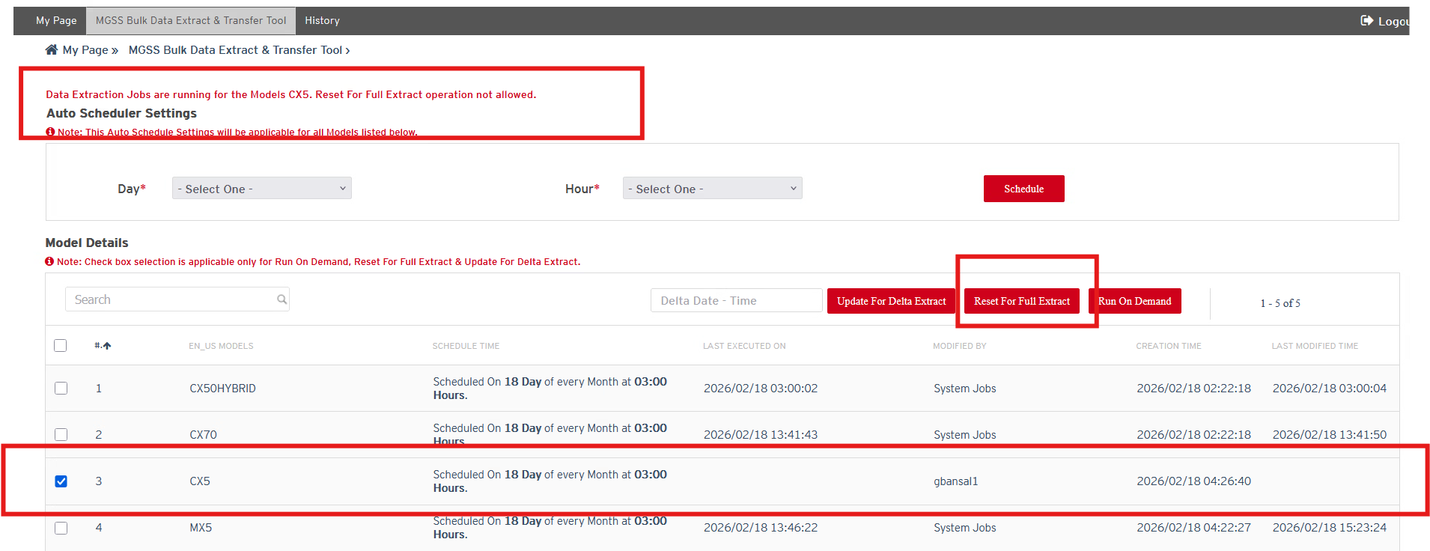

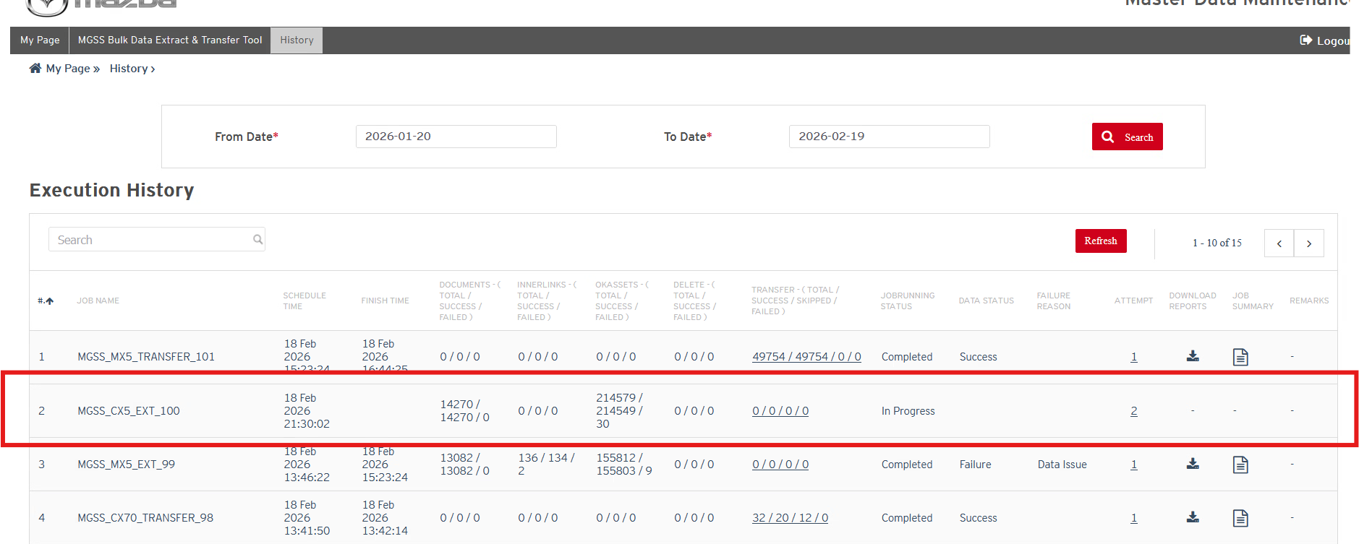
Status: Pass
Remarks:

Reset Delta Data Update Button Feature
- If user wants to extract the delta data content of particular selected model anytime in system before “Last Executed on“ timestamp then user can press the “Rest for Delta Data Update” button and can set the “Last Executed On” timestamp prior to existing “Last Executed on” value then Auto scheduler or on Demand schedule should re-extract the based on updated “Last Executed On” value in system.
Expected Result:
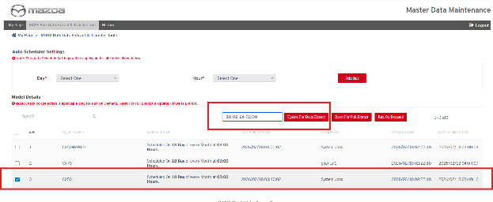
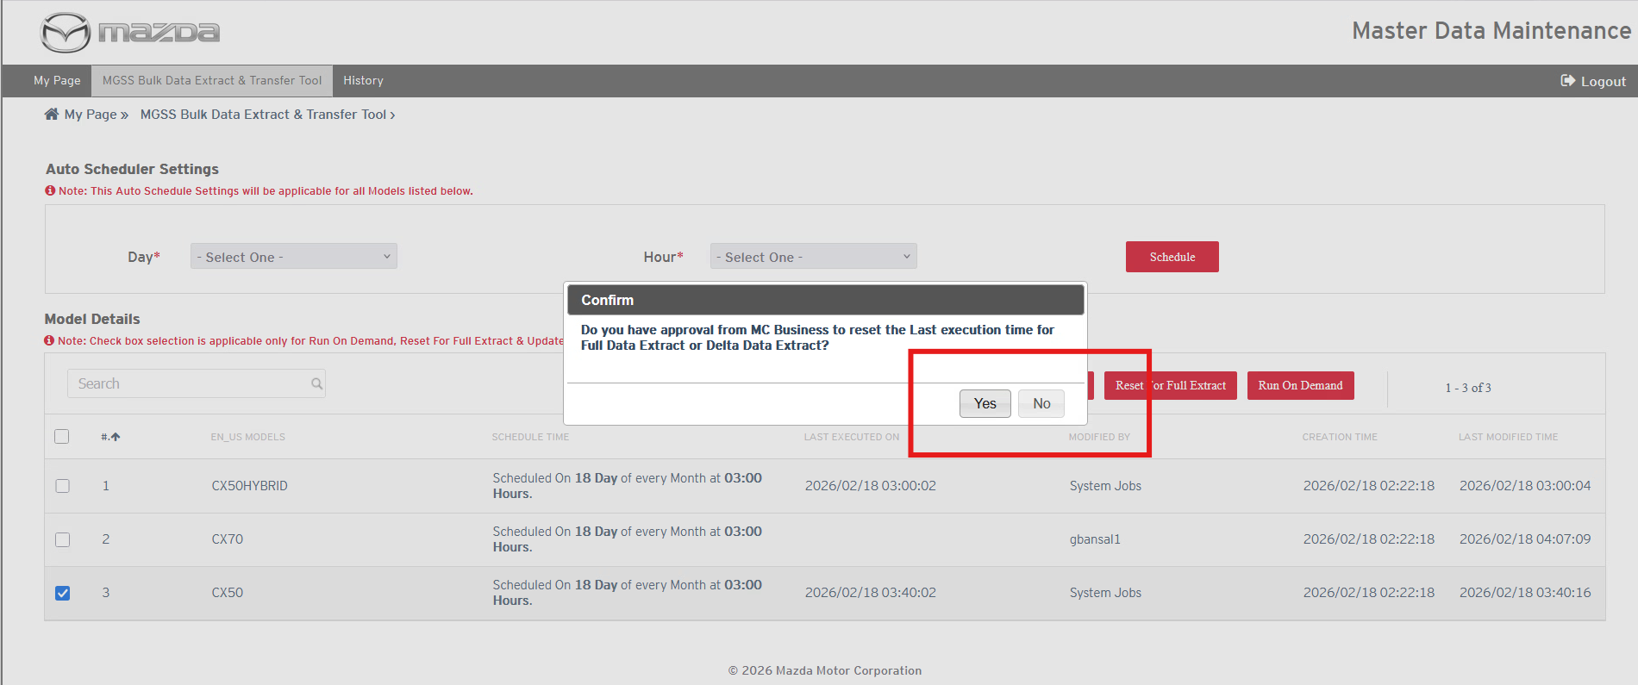
If user click on “Yes”, then it will update ‘last executed on’ time. If user click on “No” then it will not reset the existing “last executed on” timestamp.
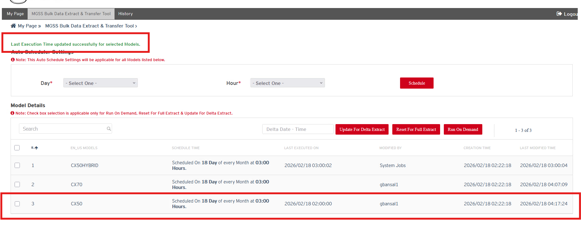

Status: Pass
Remarks:
- If user select any model to reset delta extract time where last executed on time stamp is blank then system will not allow user to reset the delta time.
Expected Result:
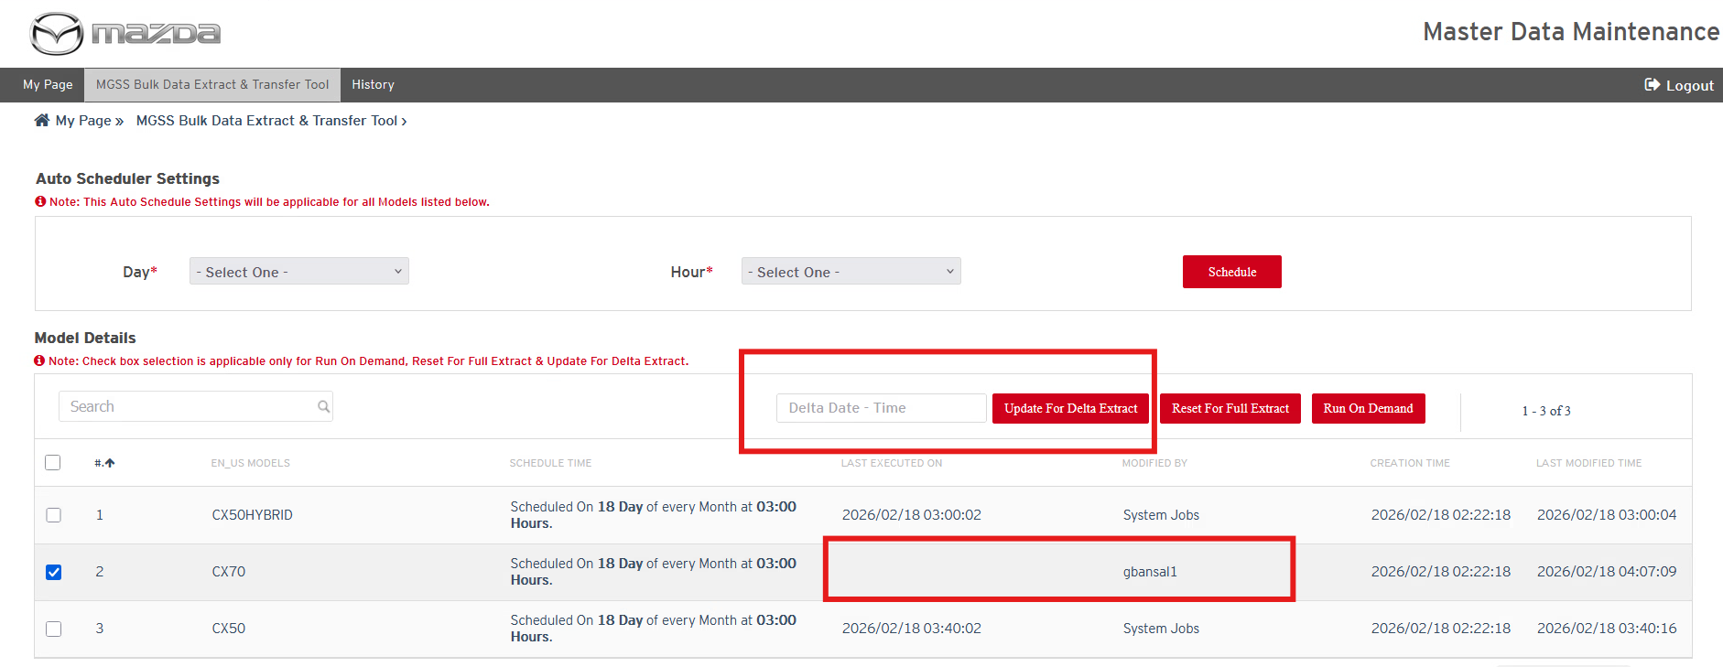
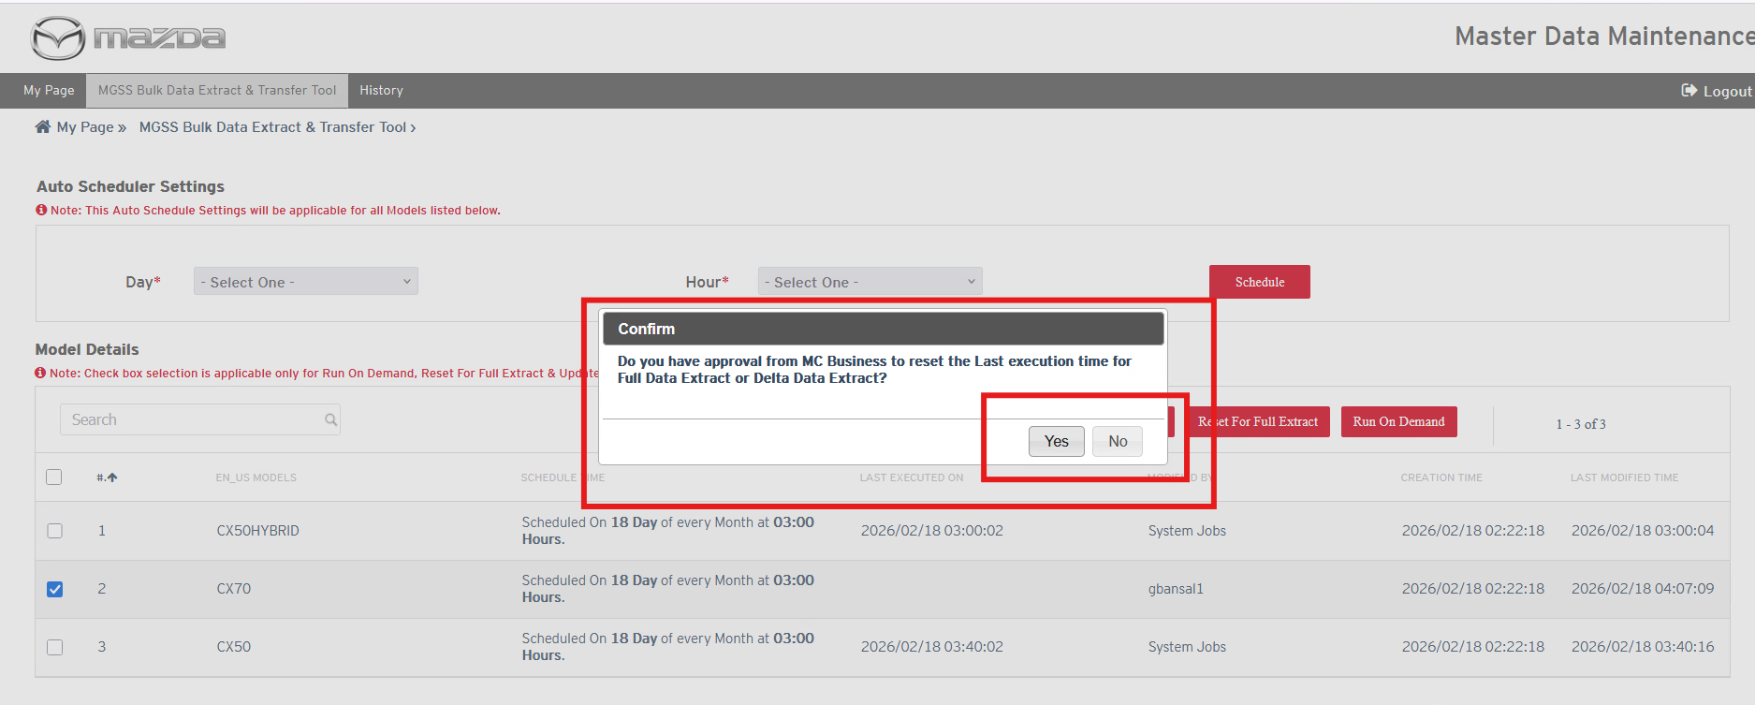
If user click on “Yes”, then it will update ‘last executed on’ time. If user click on “No” then it will not reset the existing “last executed on” timestamp.
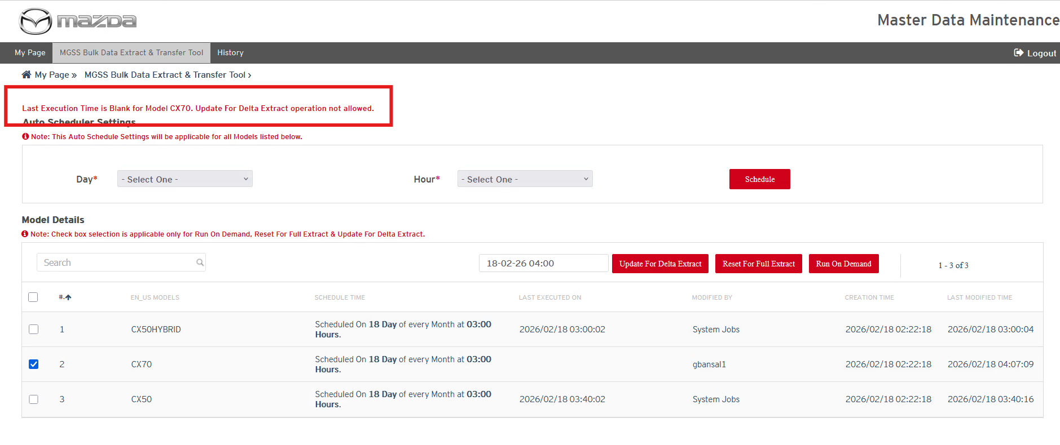

Status: Pass
Remarks:
- If user selects any model to reset delta extract time where data extraction for that model is in running state on history page then user should not be allowed to reset the delta time and should get an error message.
Expected Result:

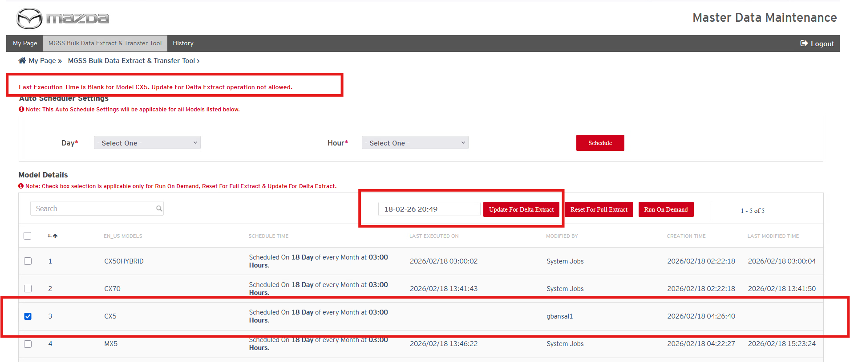

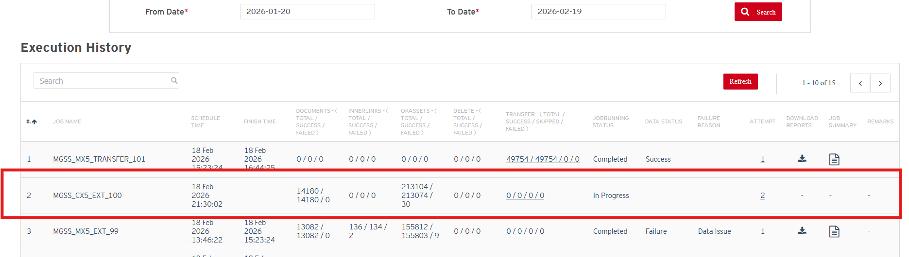
Status: Pass
Remarks:

